# **Conestoga Video Game Store**

# 

# **User Manual**

# Introduction

The purpose of this guide is to provide step-by-step instructions in the use of the Conestoga Video Game Store website.

Conestoga Video Game Store

User Manual

Introduction

Navigation to Home Page

Basic Site Navigation

Registration

Logging into an account

Top Menu/Logged On Menu

Finding friends/family

Wish List

Adding items to your wish list

Library

User Profile

Accessing the Store

Searching the Store for items

Buying an item

Adding items to your cart

Checkout of the Store

Reviewing an item

Searching for events

Registering for an event

Contact Us

Contact us by email

Contact us by phone

Contact us by mail

# Navigation to Home Page

To access the Conestoga Video Game Store the user must have an internet enabled device and a web browser. Insert into your browser address bar: www.CVGS.com

# Basic Site Navigation

Navigation points are located on the left side of the page. Highlighted by yellow box in image below.

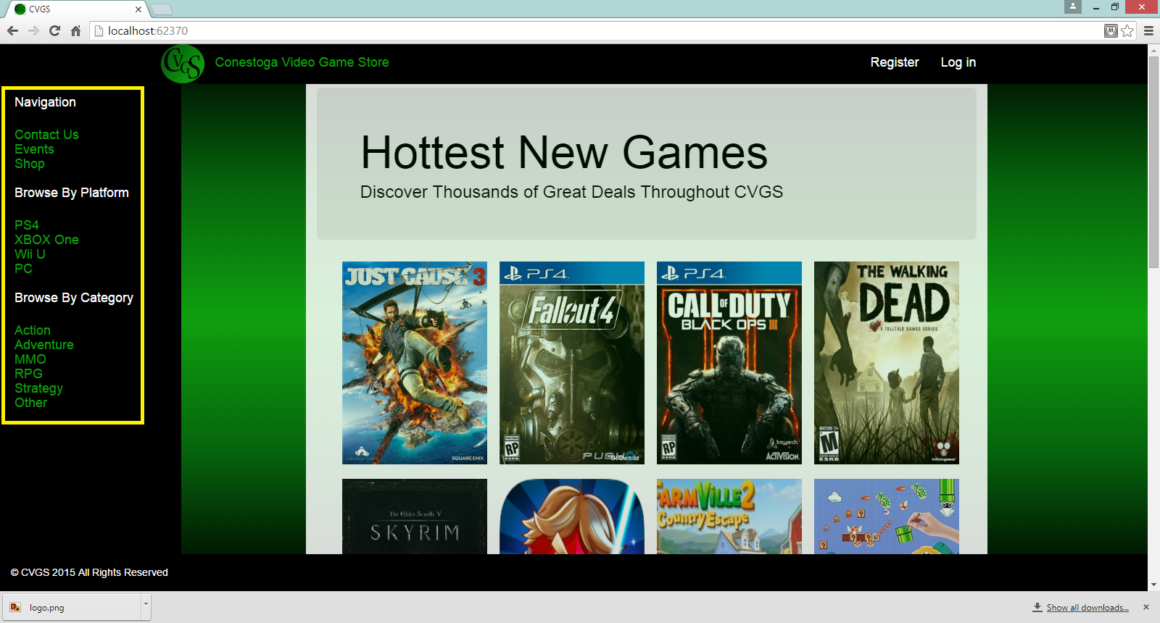

This navigation bar will always be visible no matter where you go on the Conestoga Video Game Store website so you can always quickly navigate to another area.

# Registration

To register for an account the user must click the “Registration” button in the top right of the website.

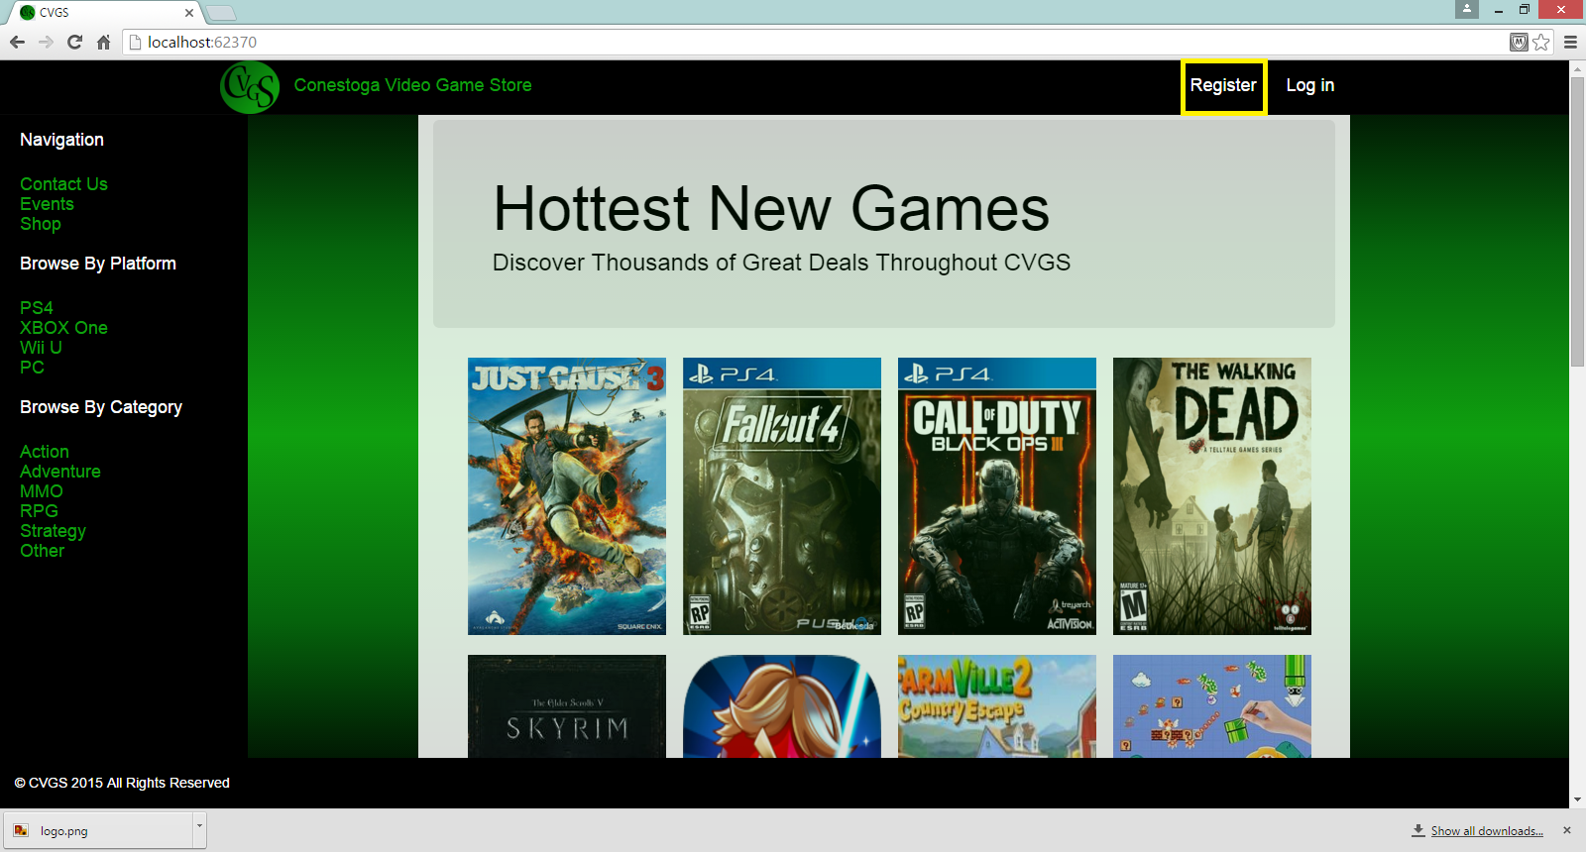

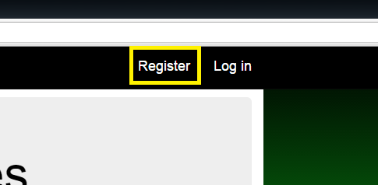

The user will then be taken to the registration form.

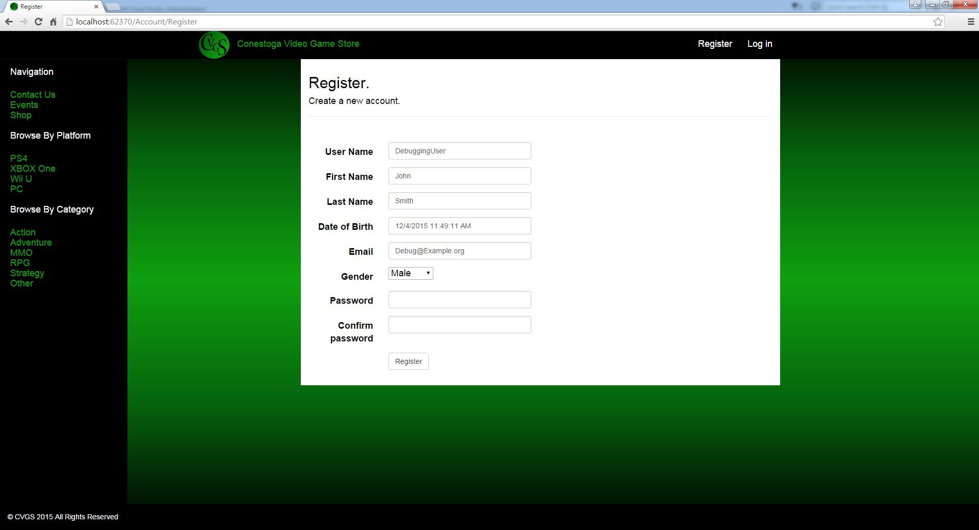

Here you will be asked to enter some basic information about yourself:

1. User Name - This is the screen name that will appear for user reviews, wish lists, and any other area of the site where…
2. First Name - This refers to the user’s first given name. It is used for account administration and payment verification of store purchases or any other instance where the Conestoga Video Game Store may have to interact with the person behind the user name. It remains private.
3. Last Name - This refers to the user’s surname. It is used for account administration and payment verification of store purchases or any other instance where the Conestoga Video Game Store may have to interact with the person behind the user name. It remains private.
4. Date of birth - Refers to the date of birth of the registering user. This is used for user validation and for purchasing age restricted game titles.
5. Email - This is the email of the registering user. This email must be valid in order for the user to register an account. It is used in the event that a password needs to be reset, to notify the user of order status, for the user to receive promotional material (If selected in the user profile, See: User Profile), and any other situation where the Conestoga Video Game Store administration have to interact with the user. This is kept private and is not visible to other users of the Conestoga Video Game Store.
6. Password - This is a unique identifier paired with user’s username to ensure only the registered user can access their account.

Important: In the event of 3 consecutive unsuccessful logins with the username the account will be locked for 5 minutes. This is a safety feature intended to protect your account from unwanted access. If you should accidentally activate this feature, please wait for the time to pass. Your account should return to normal afterward. If you experience any difficulty please contact us (See: Contact Us) at CVGS@

# Logging into an account

If you have already registered an account you can login by clicking the “Login” button at the top right of the page.

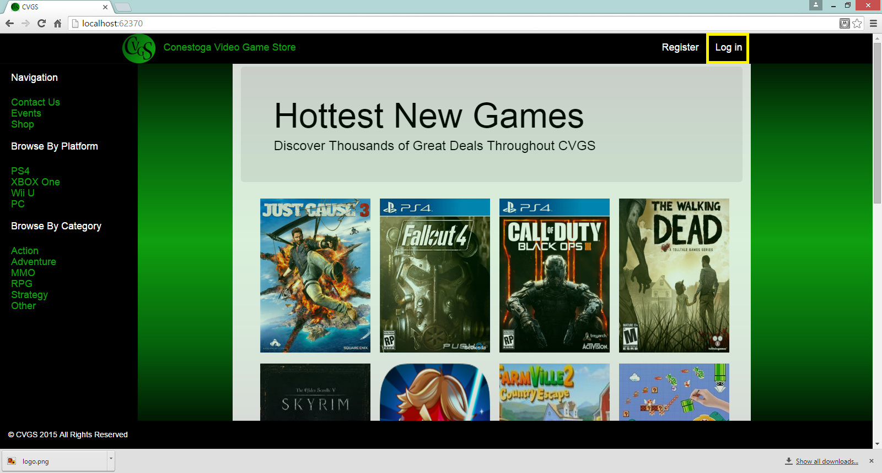

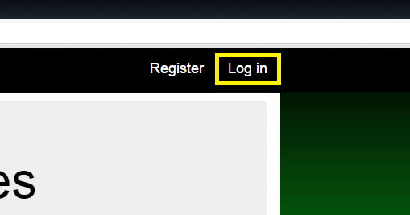

On doing so you will be prompted to enter your username and password.

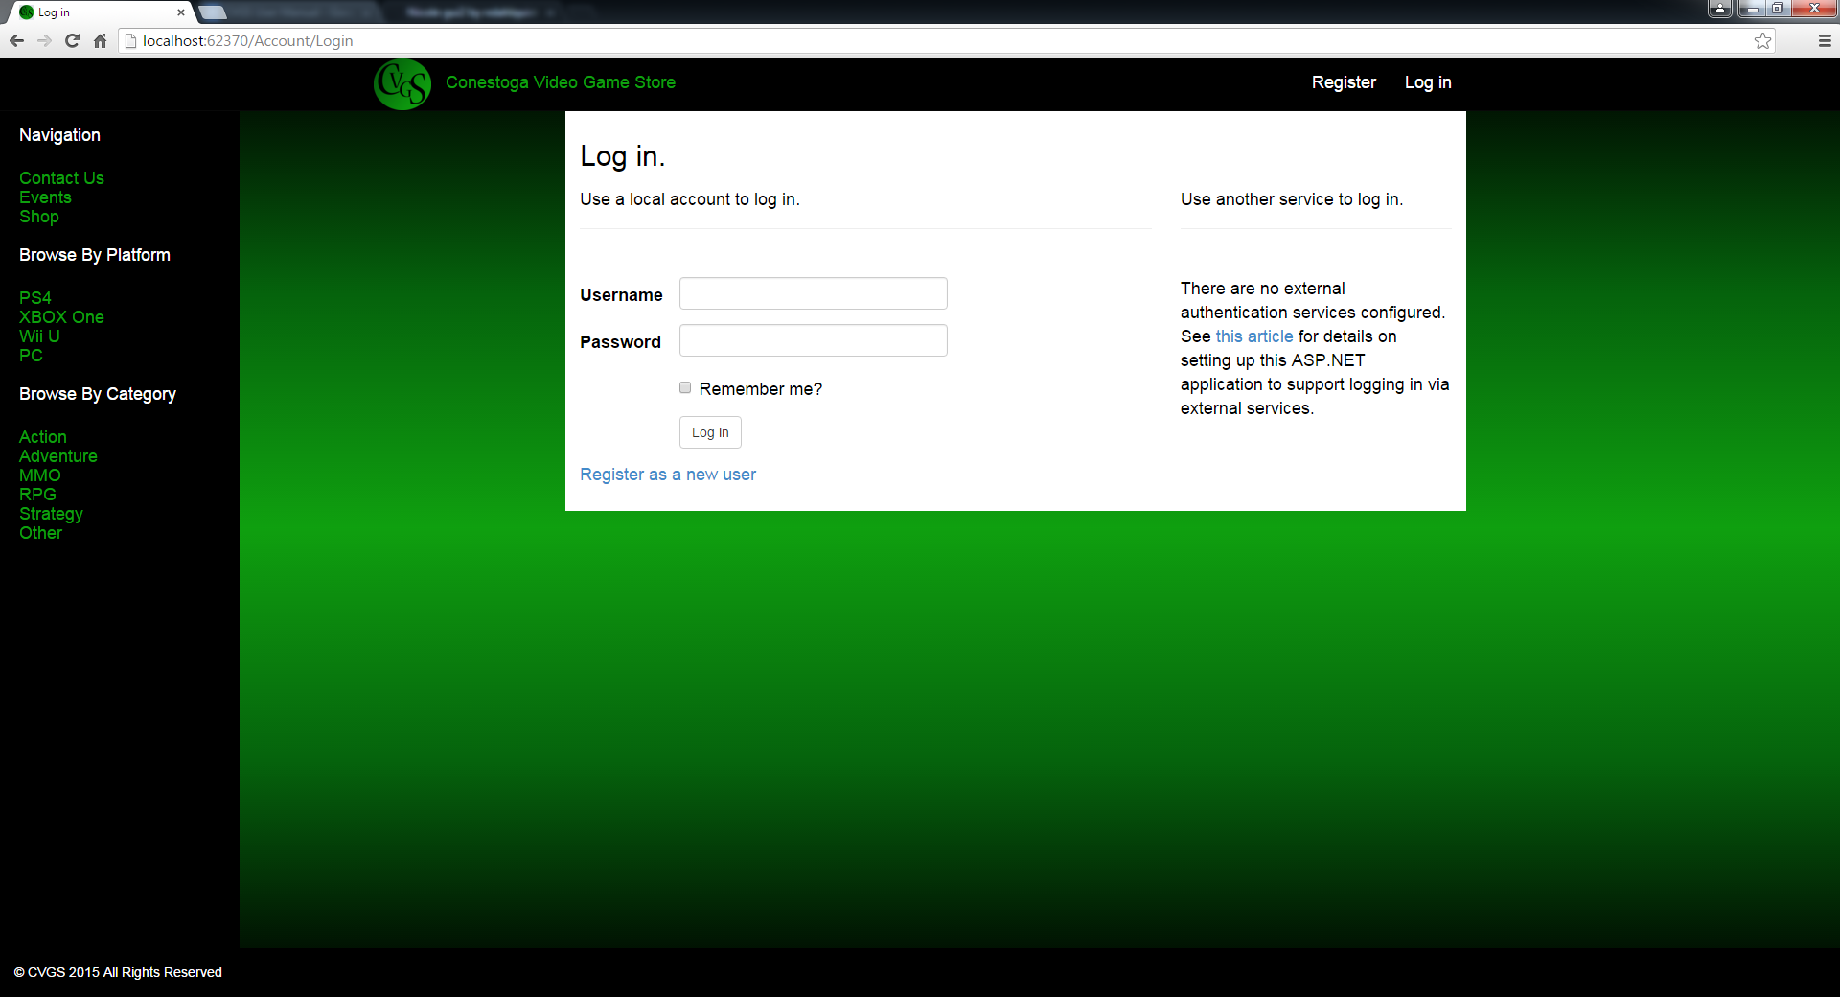

Once complete you will be taken to your account where you may shop for games, review games (See: ), register for events (See: Registering for an event), and manage your user profile(See: Profile)

Important: In the event of 3 consecutive unsuccessful logins with the username the account will be locked for 5 minutes. This is a safety feature intended to protect your account from unwanted access. If you should accidentally activate this feature, please wait for the time to pass. Your account should return to normal afterward. If you experience any difficulty please contact us (See: Contact Us) at CVGS@

# Top Menu/Logged On Menu

Upon logging in you will have additional menu options across the top of the CVGS page.

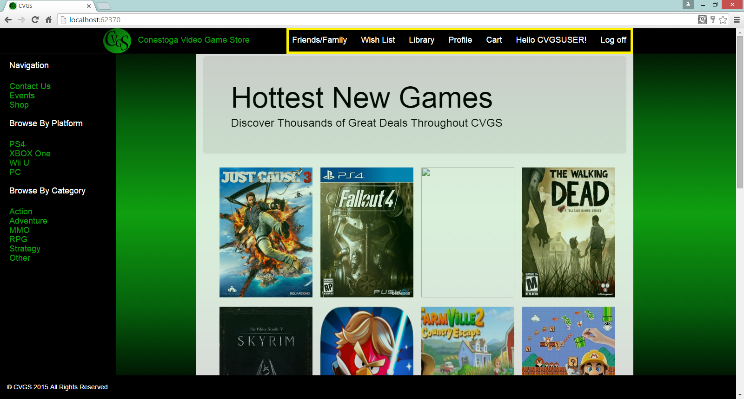

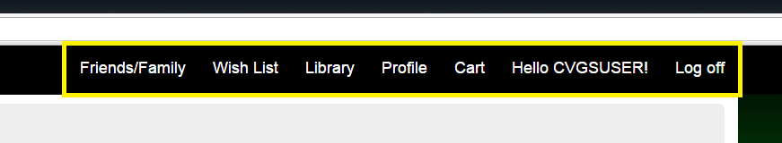

## **Finding friends/family**

The first tab available to logged in users allows you to connect to friends and family.

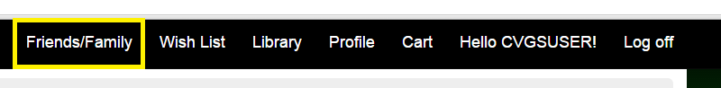

On clicking the tab you will be taken to a page that will allow you to search friends and family by name. <insert image> Enter a name in the text box and click search. When results are returned you may add the chosen people to your “Friends” or “Family” list <insert image>

## **Wish List**

The “Wish List” feature of the Conestoga Video Game Store allows you to keep track of items you may want to purchase. The list is also visible to friends and family so it allows for easy gift giving.

## **Adding items to your wish list**

To start adding items to your wish list, search for a game (See: Searching the Store for items). On finding an item of interest, click the “Details” tab. Among the options presented will be “Add To Wishlist” tab.

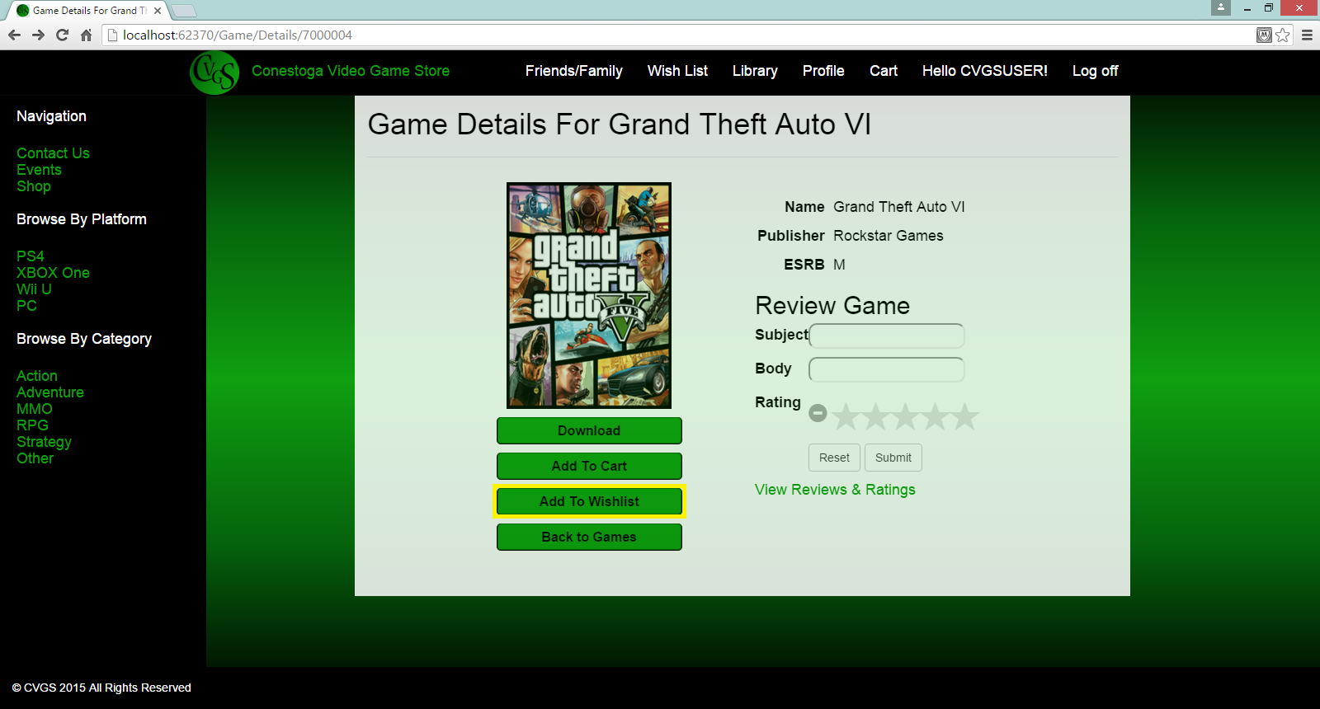

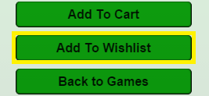

With a click, this item will be saved to your personal wish list. To view items in your wish list click “Wish List” in the top bar.



You will then be taken to your wish list items.

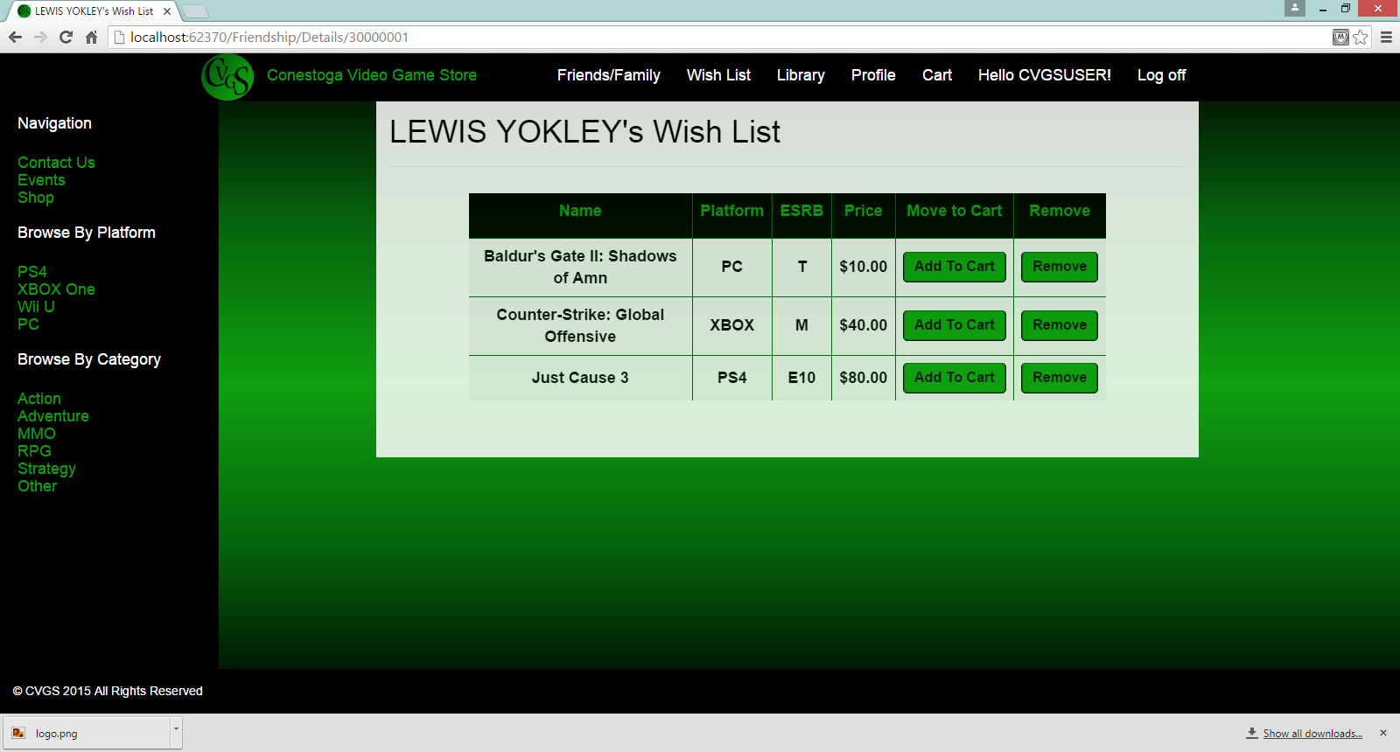

## **Library**

The library tab contains a list of items you have purchased from The Conestoga Video Game Store

## **User Profile**

The “Profile” button will allow you (if you are logged in) to edit your user profile.

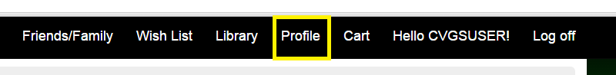

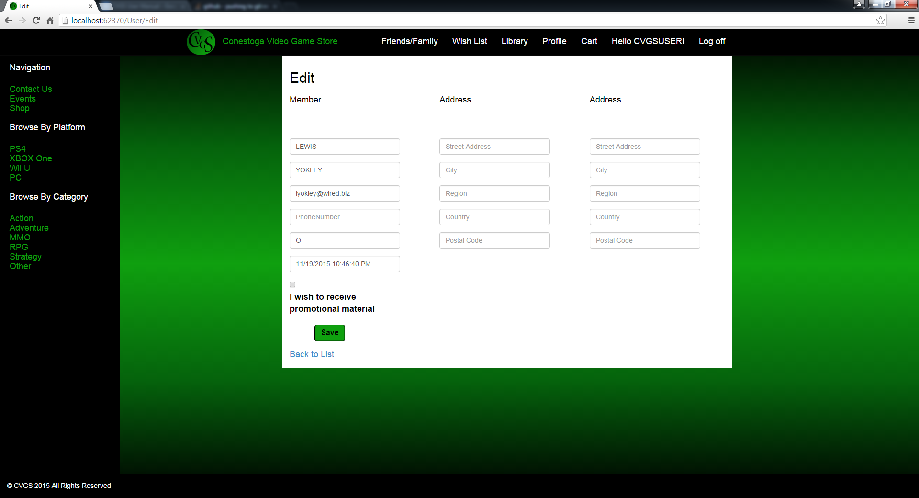

You may edit things like your name, email, phone, and also select your preference for promotional materials.

# Accessing the Store

## **Searching the Store for items**

To search for a game you may click one of the available categories on the left navigation bar.

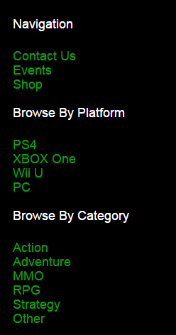

You may browse by platform or game category preference. If none of the pre defined categories interest you, you may also enter your own search criteria.

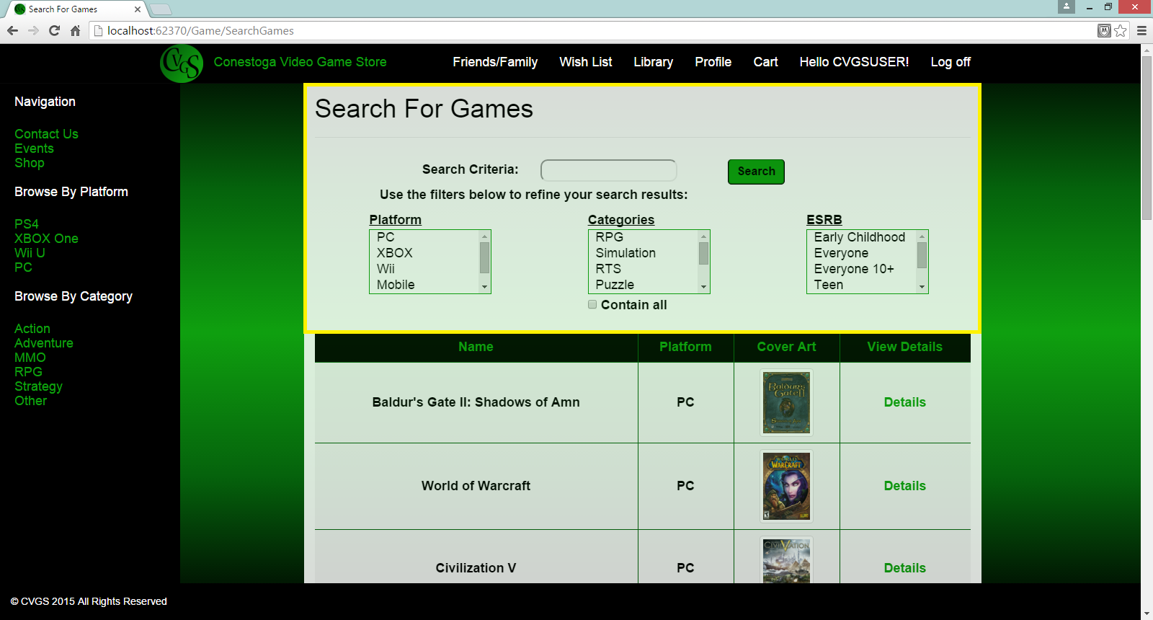

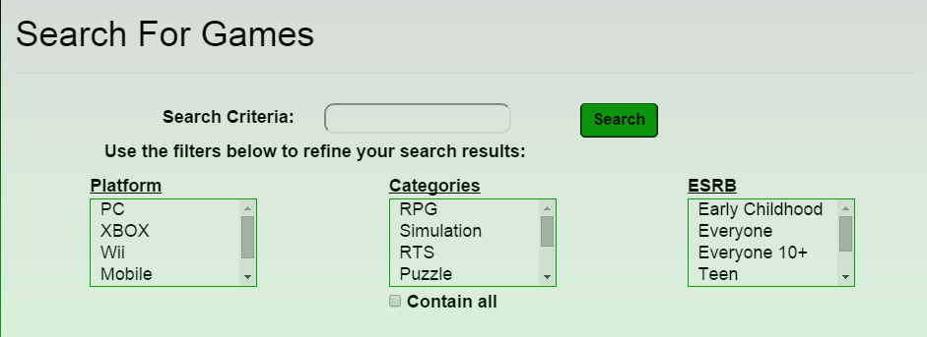

# Buying an item

In order to buy an item you must be registered and logged into your user account. After locating a game that interests you (See: Searching the Store for items), you can click on the game “Details” tab to the right of the cover art in the “View Details” column and get further details about the game including purchase options.

## **Adding items to your cart**

To add items to your cart for purchase, first search for and find a game (See: Searching the Store for items). Click the “Details” tab. You will be presented with the option “Add To Cart”

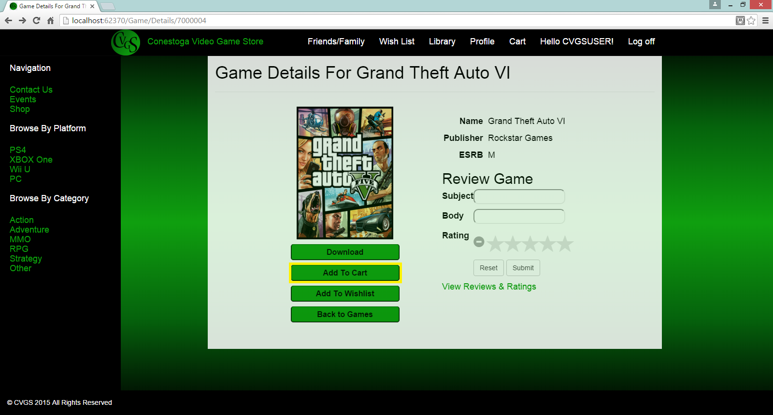

When clicked the item will then be added to your cart, which you can view by clicking the “Cart” tab in the top bar menu.



## **Checkout of the Store**

# Reviewing an item

In order to review a game you must first search for a game (See: Searching the Store for item). Upon finding the game you are interested in, view the “Details” tab of your chosen game. On clicking, you will be presented with the game details which include options to review the game.

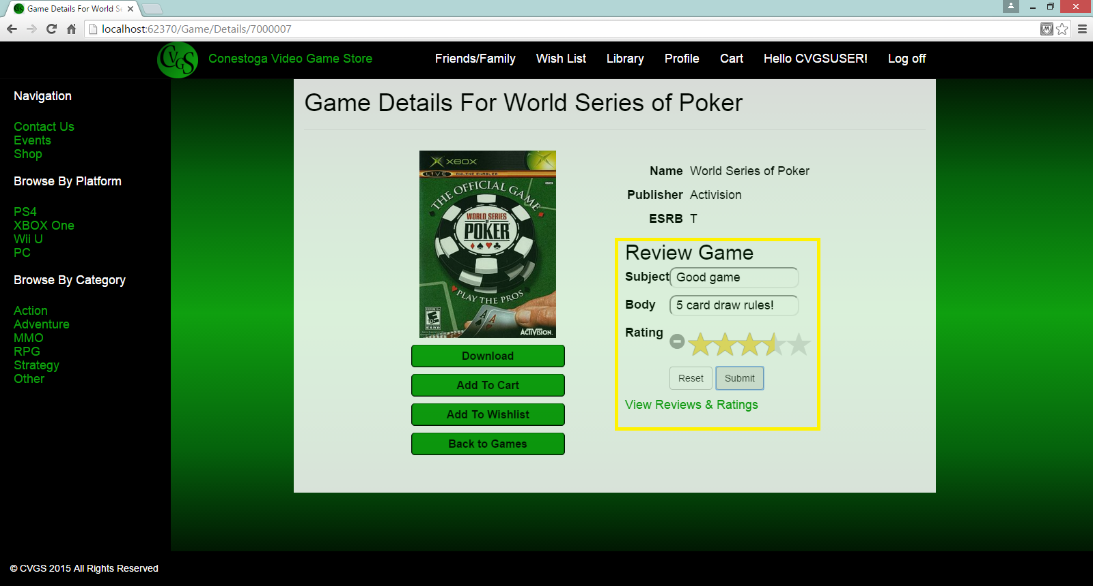

# Searching for events

# Registering for an event

# Contact Us

## **Contact us by email**

email

## **Contact us by phone**

Phone: 519-748-5220

## **Contact us by mail**

299 Doon Valley Drive

Kitchener, Ontario N2G 4M4, Canada